HCI Schedule

1. a) Eight Disciples associated with Human Computer Interaction Disciples are: **Sociology, Arts, Design, Engineering, Artificial Intelligence, Linguistics, Philosophy** and **Ergonomic**.

b) **Affordance** design principle allows the devices to be easily designed in a certain way. This is resulting of an expected typically behaviour. It can also be tested with more effective feedback as a result.

**Mapping** allows the design to be visually appealing to the end user and allow extra functionality for the user. Not only with it allow the ability to cater to all users regardless of size or ability, but allows information to be spread over the page(s) as to not bulk too much at the user itself.

c) Depending on the depth of the novice ability. Assuming the person has used a similar device before. They could use their understanding of the **mental model** to navigate around the device using the assistance of the **metaphors** on the device itself. However, someone who has never used a device before would blindly follow each metaphor if it links to their language and understanding of what it is supposed to do. They eventually understand the mental model of the system but it will take longer than someone who have used a similar device.

d) **Prototyping is a useful tool in building a user interface device** as it has constant in user feedback and designing adhering to the requirements that the user requested. As a result, the final product can be designed with more efficiency as there will be a stage where the prototype has the requirements need for the new design. It is more focused driven to cater to the users needs rather then what the designers thinks is the users need. As a result, there will be more satisfactory to both the end user and the designer.

e)

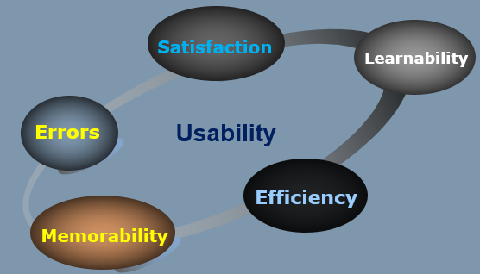

f) The four prototyping tools for evaluation are: **Expert evaluation** (such as heuristics and walk though), **Predictive evaluation** (such as testing against an engineering model) **Empirical evaluation** (watching the user use the product and document results) and **conceptual evaluation** (reviewing the development steps for improvement on design product)

1. a) 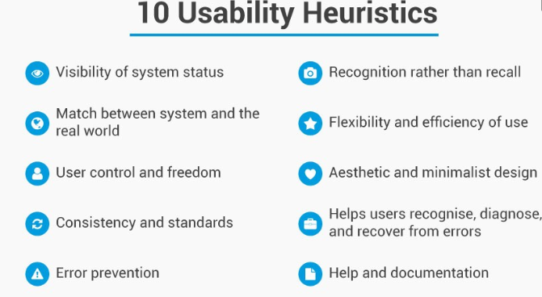

b)

Detects both major (42%) and minor (32%) problems in user interaction design

It allows for a quicker and more realistic approach on their design

Doing it properly is not as cheap as the heuristics make it appear.

Maybe outdated by the new technologies, such as VR and AR technologies

c)

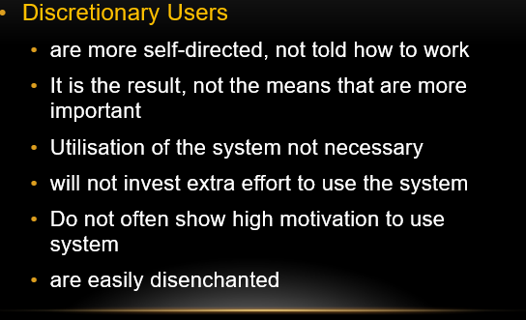

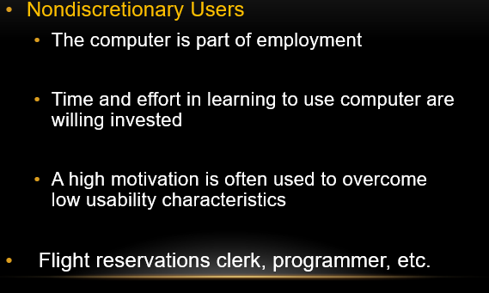

1. a)

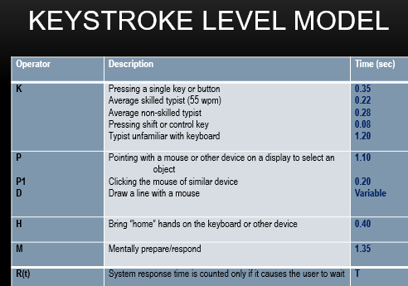

b) Define user interface and Usability

c)

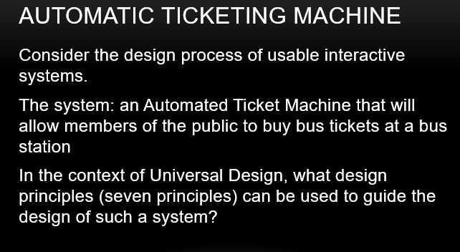

1. a) The concept of [Interaction Styles](https://www.interaction-design.org/literature/topics/interaction-styles) refers to all the ways the user can communicate or otherwise interact with the computer system. The concept belongs in the realm of HCI or at least have its roots in the computer medium, usually in the form of a workstation or a desktop computer. These concepts do however retain some of their descriptive powers outside the computer medium. For example, you can talk about menu selection (defined below) in mobile phones.

Direct Manipulation vs Command Line

b) advantages

c) disadvantages

d)

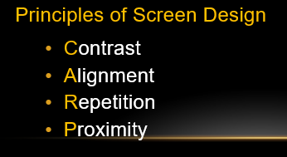

e) 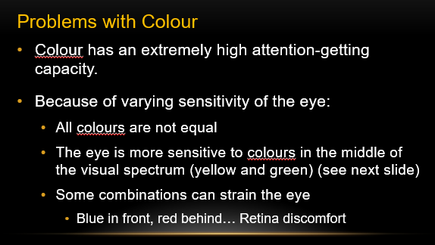

f)

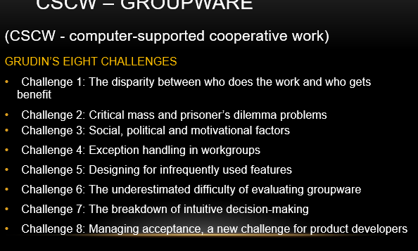

g) 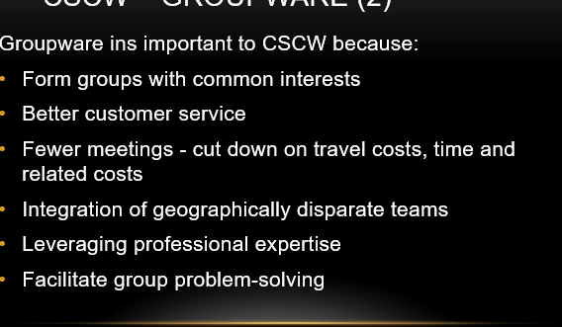

Exam Questions on the following page

